Message Authentication Code (MAC)

MAC algorithm is a symmetric key cryptographic technique to provide message authentication. For establishing MAC process, the sender and receiver share a symmetric key K.

Essentially, a MAC is an encrypted checksum generated on the underlying message that is sent along with a message to ensure message authentication.

The process of using MAC for authentication is depicted in the following illustration −

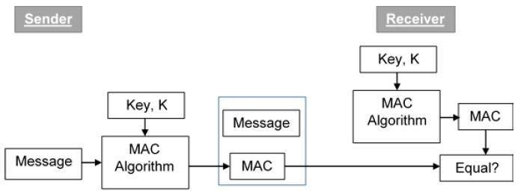

Let us now try to understand the entire process in detail −

* The sender uses some publicly known MAC algorithm, inputs the message and the secret key K and produces a MAC value.
* Similar to hash, MAC function also compresses an arbitrary long input into a fixed length output. The major difference between hash and MAC is that MAC uses secret key during the compression.
* The sender forwards the message along with the MAC. Here, we assume that the message is sent in the clear, as we are concerned of providing message origin authentication, not confidentiality. If confidentiality is required then the message needs encryption.
* On receipt of the message and the MAC, the receiver feeds the received message and the shared secret key K into the MAC algorithm and re-computes the MAC value.
* The receiver now checks equality of freshly computed MAC with the MAC received from the sender. If they match, then the receiver accepts the message and assures himself that the message has been sent by the intended sender.
* If the computed MAC does not match the MAC sent by the sender, the receiver cannot determine whether it is the message that has been altered or it is the origin that has been falsified. As a bottom-line, a receiver safely assumes that the message is not the genuine.

Limitations of MAC

There are two major limitations of MAC, both due to its symmetric nature of operation −

* **Establishment of Shared Secret.**
  + It can provide message authentication among pre-decided legitimate users who have shared key.
  + This requires establishment of shared secret prior to use of MAC.
* **Inability to Provide Non-Repudiation**
  + Non-repudiation is the assurance that a message originator cannot deny any previously sent messages and commitments or actions.
  + MAC technique does not provide a non-repudiation service. If the sender and receiver get involved in a dispute over message origination, MACs cannot provide a proof that a message was indeed sent by the sender.
  + Though no third party can compute the MAC, still sender could deny having sent the message and claim that the receiver forged it, as it is impossible to determine which of the two parties computed the MAC.

Both these limitations can be overcome by using the public key based digital signatures discussed in following section.